Data Analytics

1

SESSION 19: TABLEAU DESKTOP

(CONTD.)

Assignment 2

Data Analytics

2

Table of Contents

1. Introduction .......................................................................................................................................... 3

2. Objective ............................................................................................................................................... 3

3. Prerequisites ......................................................................................................................................... 3

4. Associated Data Files ............................................................................................................................ 3

5. Problem Statement ............................................................................................................................... 3

6. Expected Output ................................................................................................................................... 3

7. Approximate Time to Complete Task ................................................................................................... 3

Data Analytics

3

**1. Introduction**

This assignment will help you understand the concepts learnt in the session.

**2. Objective**

To understand the concepts in Tableau.

**3. Prerequisites**

Not applicable.

**4. Associated Data Files**

N/A

**5. Problem Statement**

1. Create a Filled map by using the column State. Denote each state with different colors.

2. Show the State Name and Total Sales in the lables

3. Show the tooltip with State Name, Profit and Sales

**6. Expected Output**

N/A

**7. Approximate Time to Complete Task**

**Solution#**

**Please find the attached solution sheet.**

In first step we will create a filled map using state details.

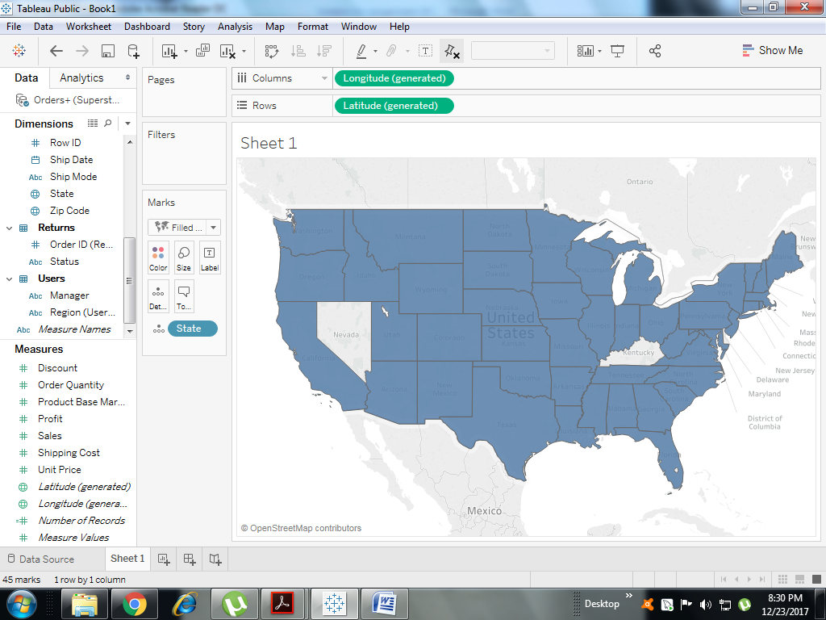

In second step we will change color for state

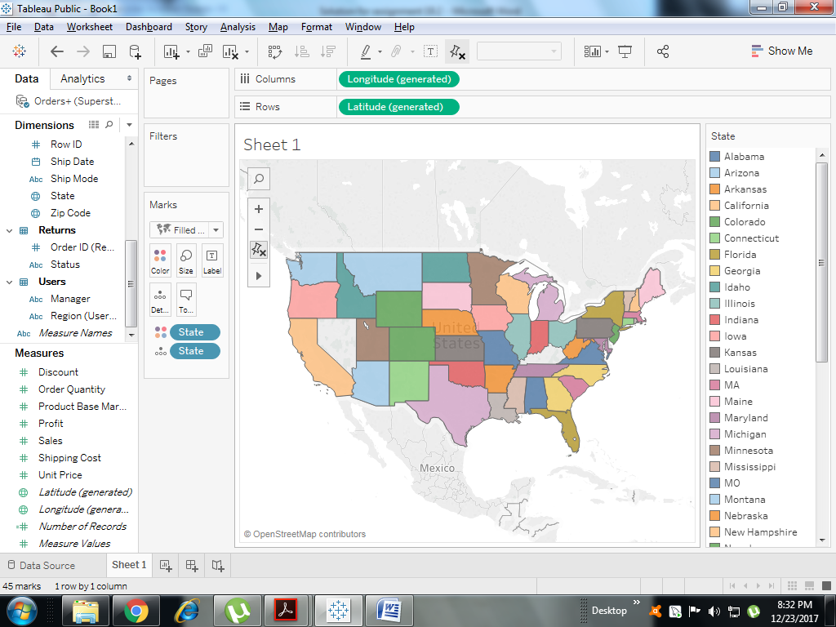

In third step we will put state and sale under lables.

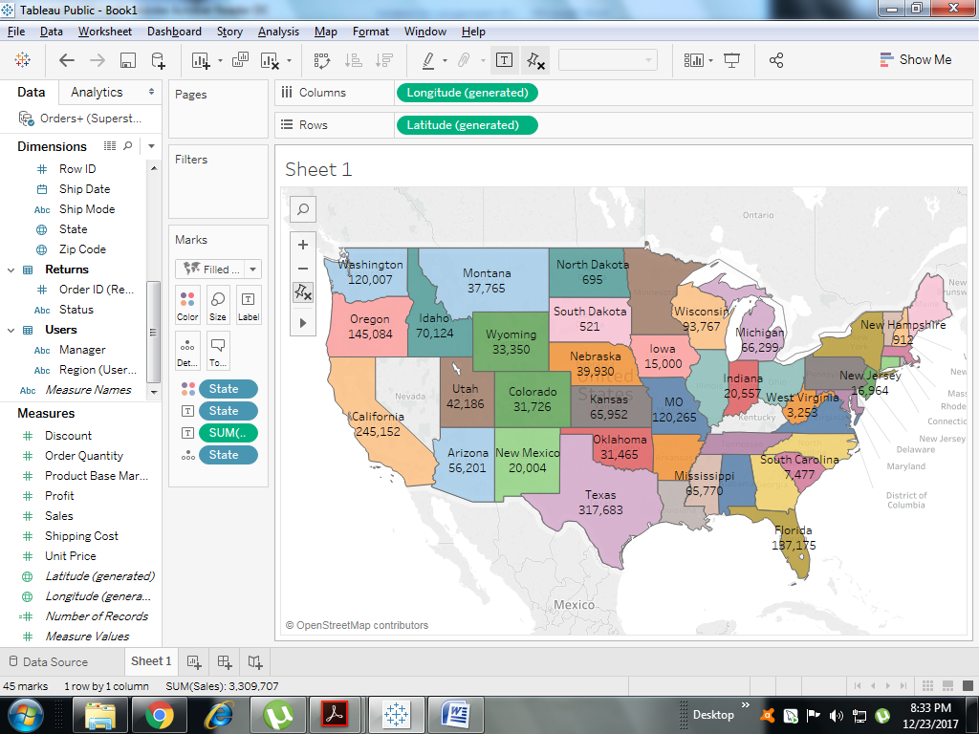

**For better description we can edit tool tip.**

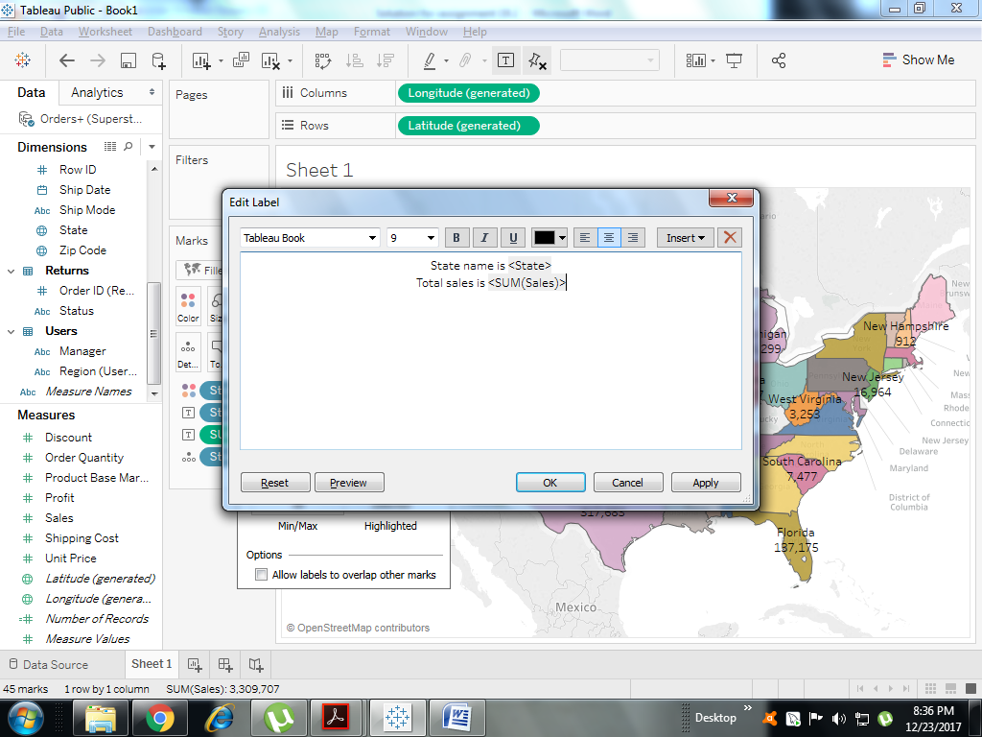

**Result will be like the attachment below.**

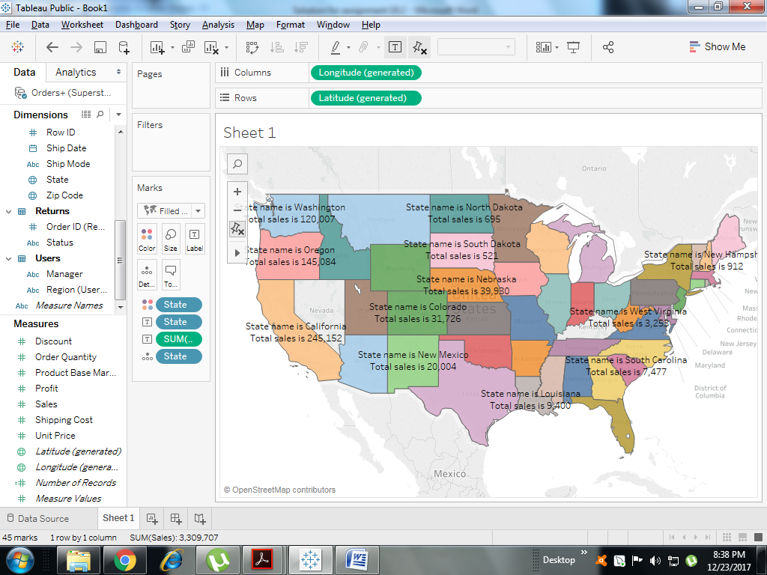

In next step we can drag down State , profit and sales under tool tip. Now, if you move your mouse at different status you will get the full detail about state name, sum of sales and sum of profit.

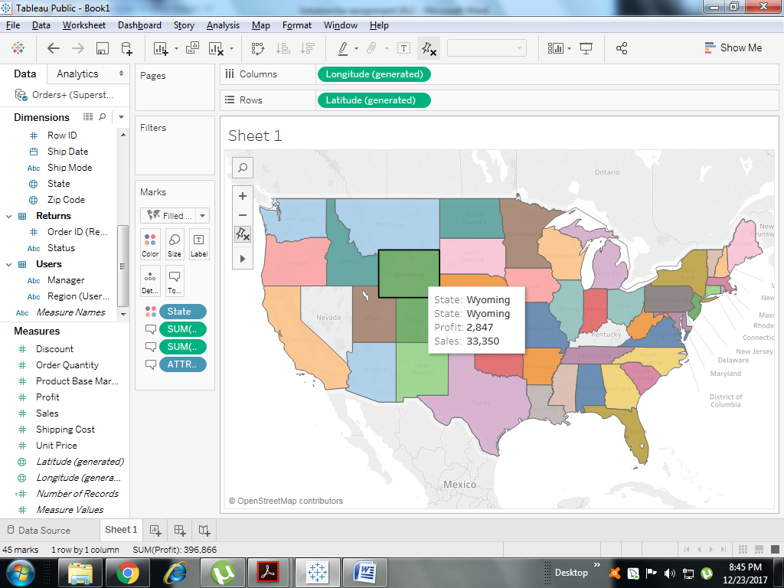

We can also edit tool tip in same way we edited Labels to have a better understanding for end users.

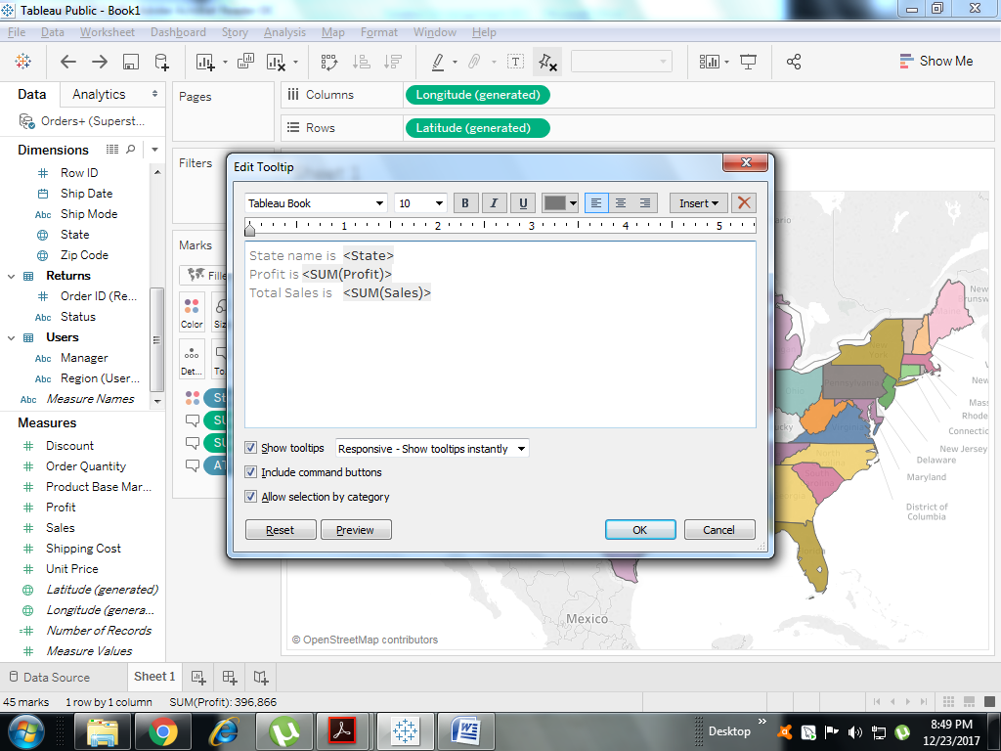

And the improvised result will look like this.

